Full Stack ML Pipeline on GCP: Application, Database, Training, and Prediction Service
- GCP VM Setup.

Navigate: Compute Engine → VM Instance
OS: Ubuntu 22.04 LTS - Machine type: e2-medium
Firewall: Allow HTTP & HTTPS - SSH into the VM.
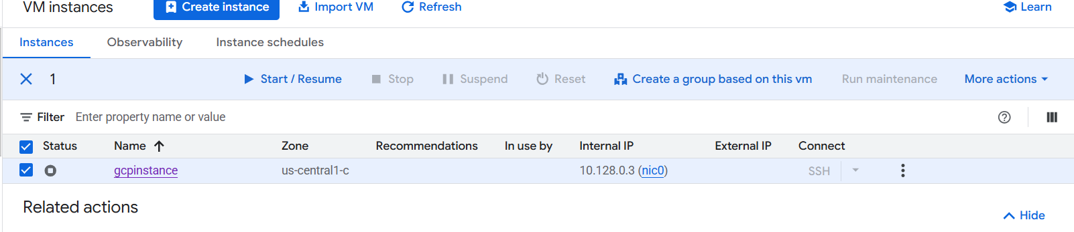

- Install Application Dependencies.
sudo apt update && sudo apt upgrade -y
sudo apt install -y python3 python3-pip git
pip3 install fastapi uvicorn[standard] pandas scikit-learn python-multipart.

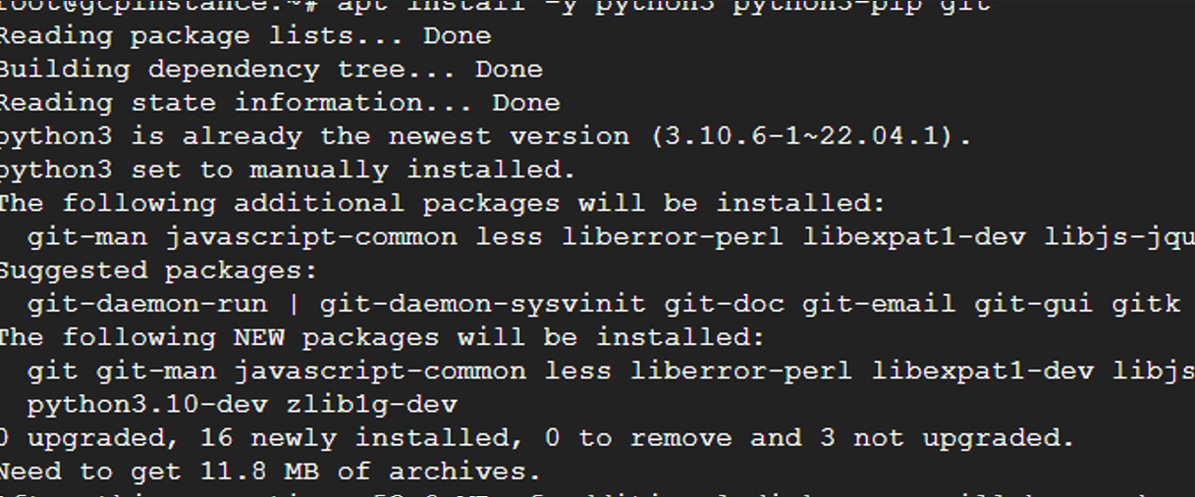
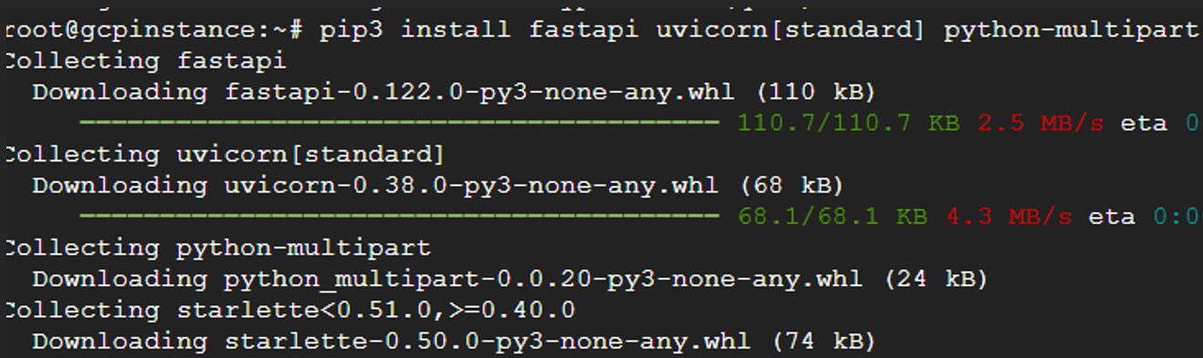
3.Create Application Folder
mkdir gcp_ml_app && cd gcp_ml_app
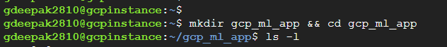
4.Create Application API (Stores Data)
nano app.py
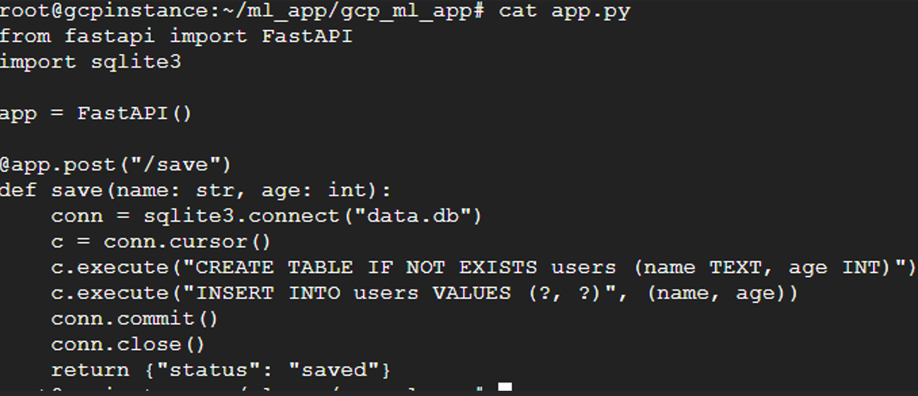
Run the API:
uvicorn app:app --host 0.0.0.0 --port 8000
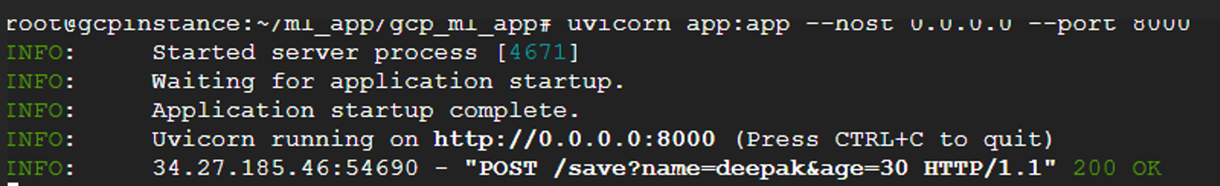
3.Insert Data.
curl -X POST "http://<EXTERNAL-IP>:8000/save?name=deepak&age=30"
curl -X POST "http://<EXTERNAL-IP>:8000/save?name=john&age=25"
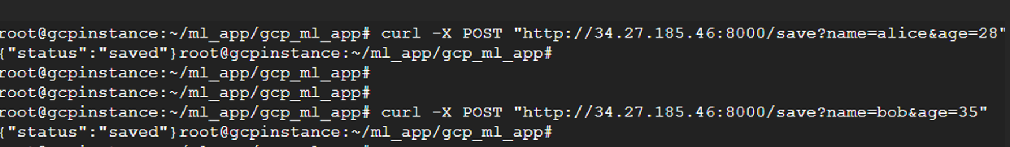
- Train an ML Model on VM.
Nano train.py
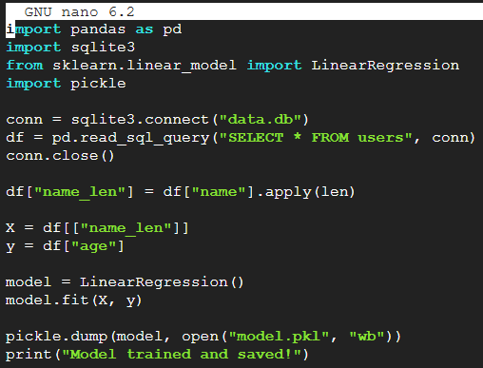
- Train the model.
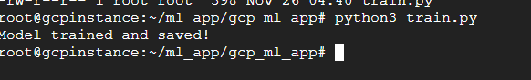
- Deploy ML Prediction API
Nano Predict.api
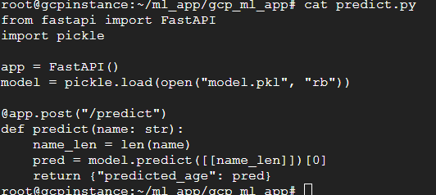
Run prediction API:
#uvicorn predict:app --host 0.0.0.0 --port 9000
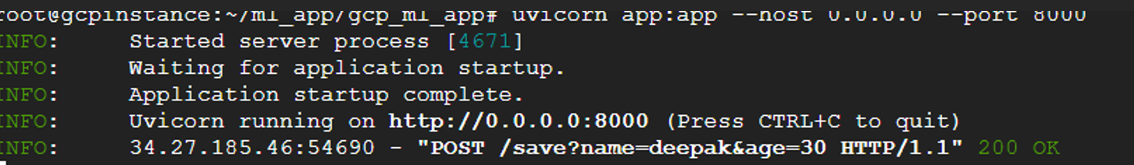
- Test Prediction API.
- Persistent Storage & Dockerization.
Install Docker.
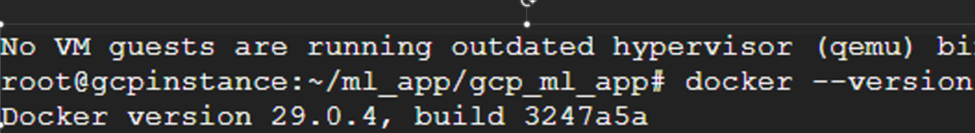
- Docker Build with Fastapi and Sqllite application.
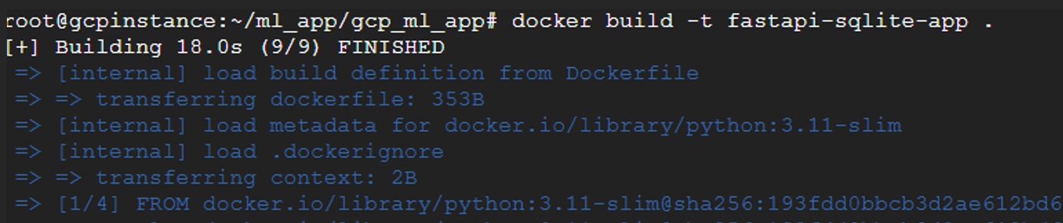
- Reload the app.
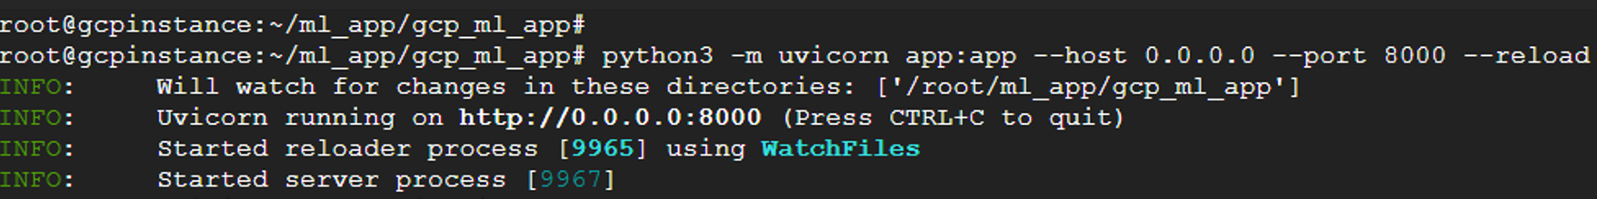
- Test in browser.
http://34.27.185.46:8000/docs
